##### Hotel Management System

* GROUP MEMBERS:
* MUHAMMAD UMAR KHAN 10619
* SHAIKH RAMEEZ AZHAR 10394
* SHOIAB AHMED 10621
* CONTENTS:
* ORIGIN
* BACKGROUND
* PROBLEM STATEMENT
* WHERE PROJECT COMES FROM AND WHAT PROBLEM IT SOLVES
* DIAGRAMS:
* DATABASE DIAGRAM
* ERD
* BUSINNESS FLOW DIAGRAM
* MULTI-VENDOR CONTROL
* ORIGIN:

Hotel management system is a very old management system and it has been in working since the hotels were first formed. Initially, there were no computers to store record of customers which arrive and leave the hotel therefore all the records were written on a piece of paper or a notebook.

* BACKGROUND:

The first hotel reservation system was not introduced until 1947 by Westin. In those early days, there was not much in the way of technology, and many hotels were simply using their register to keep track of the guests who were booking rooms and who were checking into the hotel. Given just how busy the hotel industry is today, it is almost impossible to imagine what it would be like to have to take care of everything with a register at the front desk.

It wasn’t until 1995 that guests to hotels were offered real-time access to central reservations and online booking at hotels. Of course, the first hotel chain websites had only been launched a year prior. These were for Hyatt and Promus Hotel Corporation.

The early [hotel property management systems](https://www.hotelogix.com/hotelogix-cloud-based-property-management-system.php?utm_medium=referral&utm_source=hotelnewsresource&utm_campaign=evolution-of-hotel-property-management-systems-tpa-/25/03/2020)through the 1970s were quite varied from one hotel chain to another. As time passed and software systems were introduced, there was more of a unified style of PMS. Many hotels and chains would invest in in-house and server-based systems once computers became commonplace. The systems were updated and upgraded every few years in the computer age, and it was in 2010 that the first-gen of cloud PMS was released. In the past 10 years, these systems have continued to improve and change.

It’s no stretch to say that the improvements to PMS as a part of hotel management solutions have changed the way that hoteliers do business. These systems are able to provide a wide range of tools and technology today that are making managing every aspect of the business so much faster and more efficient

The advantages of PMS in the front office can’t be overstated. The systems are able to provide tools that help to integrate and streamline are more than just the front office, though. It helps with a point-of-sale solutions, online distribution, managing all of the channels through which the hotel offers rooms, housekeeping, and beyond. The right software can even help with things like staff training. There are many modules of a property management system that will help make running the hotel much easier.

* PROBLEM STATEMENT:

At first when the hotel management systems were managed on paper, the problems that aroused were:

1. Handling a lot of customers that walks in at the same time
2. There were chances that incorrect data could be entered
3. The hotel had to know that how many staff are on duty and how many are not every time
4. The hotel has no information about how many rooms are busy and which are vacant unless they visit them themselves
5. The hotel bill was calculated manually which caused problems or human error some times
6. The hotel staff had to give information about the meals of the client to the kitchen manually
7. The paper pen system they followed was very time consuming
8. There was no privacy of the record and the changes were there that the records could be lost/stolen/burned
9. The hotel management needed to know time to time when a customer checks in or checks out that would cause a person to be employed for such duty
10. There were mis management and there were chances that wrong meals could be delivered to the wrong room
11. The hotel had no information about which of their room is ready to be used or not
12. The hotel had no information about the check in and out time of employee and duty hours also duty room

After all such time, Hotel Management Software were introduced and then used. This software solved all the problems which occurred before, the management system which were managed on papers went to cloud and database storages, this management system software solved problems like:

1. Now all the records could be stores in databases and clouds
2. Incorrect data now cannot be entered as now there is validation
3. Software keeps track of all staff on duty and free
4. Software keeps information about all busy and vacant rooms
5. The bill now is calculated through software which is very accurate and legit
6. All meal information is delivered digitally to the screens in the kitchen by the software to the related rooms
7. The registration through software is done just in few moments and it can manage many costumers at a single time
8. There is full privacy of records and there are backups in case data is damaged
9. Software keeps track of all check ins/outs
10. Accuracy of trace of meals to the registered rooms
11. Software knows all info about which room is vacant and which is busy each time a customer enters or leaves the room
12. Now this software provides trace of all check ins/check out of all employee promptly

* DATABASE DIAGRAM:



* DATABASE DIAGRAM:

ER DIAGRAM:

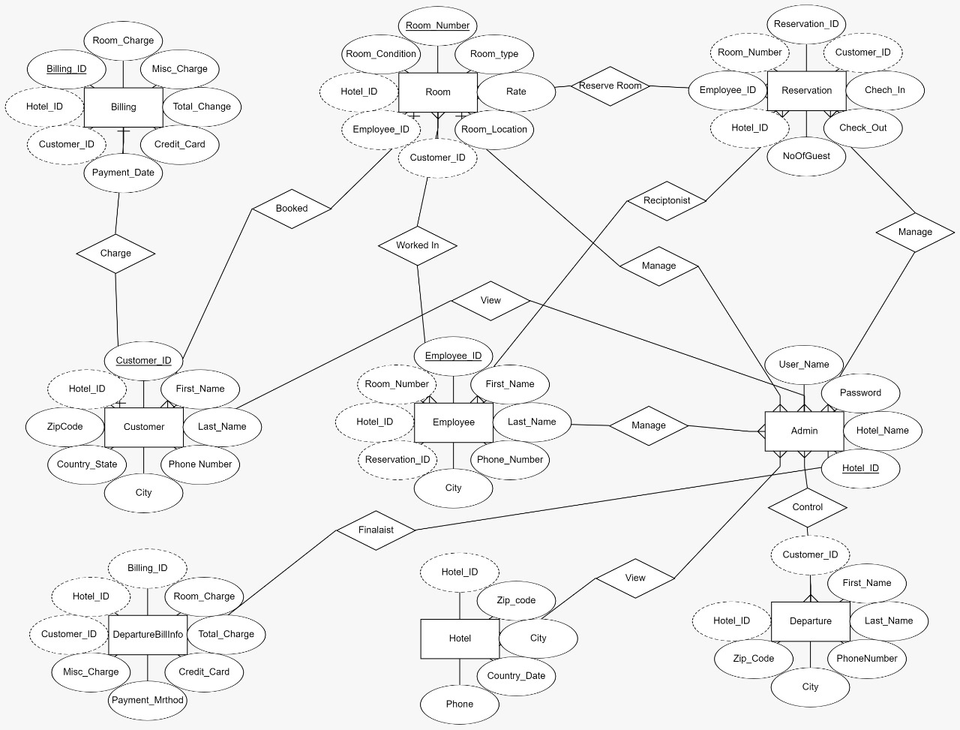

* BUSINESS FLOW DIAGRAM:

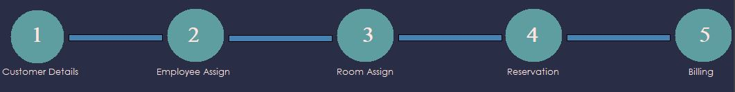

Registration & Check-In to Check-Out:

* Customer details will be filled first in the reservation process
* In the second process. Employee will be assigned and only one employee will look after one room
* In the third step, room will be assigned to the customer
* Reservation will be completed
* The last step includes saving of all data along with billing data completing the registration process of a single customer.
* MULTI-VENDOR CONTROL:

1. Would help a new vendor to sign up and log in as a new vendor
2. He doesn’t have to see information stored of other hotels
3. He will add rooms and meals also employee to the hotel then assign at the time of reservation
4. Each hotel will have a different hotel ID through which each hotel’s data will be accessed
5. Each hotel will have a separate data storage space and rooms, meal and employee
6. It will help many new vendors to register on this software and plug n play

SQL QUERRIES:

create table Admin(

Username varchar(max) not null,

Password varchar(max) not null,

Hotel_Name varchar(max) not null,

Hotel_ID bigint IDENTITY(100001,3) PRIMARY KEY NOT NULL

)

create table Hotel(

Hotel_ID bigint FOREIGN KEY REFERENCES Admin (Hotel_ID) not null,

Zipcode nvarchar(50) not null,

City varchar(20) not null,

Country_state varchar (20) not null,

Phone nvarchar(50) not null

)

create table Departured(

Customer_ID int foreign key references Customer(Customer_ID) not null,

First_name varchar(50) not null,

Last_name varchar(50) not null,

Phone_number nvarchar(50) not null,

City varchar(20) not null,

Country_state varchar(20) not null,

Zip_code nvarchar(50) not null,

Hotel_ID bigint FOREIGN KEY REFERENCES Admin (Hotel_ID) not null

)

create table DeparturedBillingInfo(

Billing_ID int IDENTITY(5001,3) foreign key references Billing(Billing_ID)not null,

Room_charge int not null,

Misc_charges int not null,

CreditCard_No bigint not null,

Payment_Date date not null,

Customer_ID int foreign key references Customer(Customer_ID) not null,

Hotel_ID bigint FOREIGN KEY REFERENCES Admin(Hotel_ID) not null

)

create table Customer(

Customer_ID int IDENTITY(1001,3) primary key not null,

First_name varchar(50) not null,

Last_name varchar(50) not null,

Phone_number nvarchar(50) not null,

City varchar(20) not null,

Country_state varchar(20) not null,

Zip_code nvarchar(50) not null,

Hotel_ID bigint FOREIGN KEY REFERENCES Admin (Hotel_ID) not null

)

create table Employee(

Employee_ID int IDENTITY(2001,2) primary key not null,

First_name varchar(50) not null,

Last_name varchar(50) not null,

Phone_number nvarchar(50) not null,

City varchar(20) not null,

Country_state varchar(20) not null,

Zip_code nvarchar(50) not null,

Hotel_ID bigint FOREIGN KEY REFERENCES Admin(Hotel_ID) not null

)

create table Room (

Room_number nvarchar(50) primary key not null,

Room_type varchar(20) not null,

Rates bigint not null,

Room_location nvarchar(20) not null,

NumberOFbeds int not null,

Customer_ID int foreign key references Customer(Customer_ID),

Employee_ID int foreign key references Employee(Employee_ID),

Hotel_ID bigint FOREIGN KEY REFERENCES Admin(Hotel_ID) not null

)

create table Reservations(

Reservation_number int IDENTITY(3001,2) primary key not null,

Customer_ID int foreign key references Customer(Customer_ID) not null,

Check_In date not null,

Check_Out date not null,

Status_current varchar(20) not null,

NumberOFguests int not null,

Reservation_date date not null,

Room_number nvarchar(50) foreign key references Room(Room_number) not null,

Hotel_ID bigint FOREIGN KEY REFERENCES Admin(Hotel_ID) not null

)

create table Plans(

Service_ID int IDENTITY(4001,3) primary key not null,

Servicename varchar(20) UNIQUE not null,

Servicecost int not null,

Reservation_number int foreign key references Reservations(Reservation_number) ,

Hotel_ID bigint FOREIGN KEY REFERENCES Admin(Hotel_ID) not null

)

create table Billing(

Billing_ID int IDENTITY(5001,3) primary key not null,

Room_charge int not null,

Misc_charges int not null,

CreditCard_No bigint not null,

Payment_Date date not null,

Customer_ID int foreign key references Customer(Customer_ID) not null,

Hotel_ID bigint FOREIGN KEY REFERENCES Admin(Hotel_ID) not null

)

create table Room_Condition(

Room_number nvarchar(50) foreign key references Room (Room_number) not null,

Room_Status varchar(max) not null,

Customer_ID int foreign key references Customer (Customer_ID),

Hotel_ID bigint FOREIGN KEY REFERENCES Admin (Hotel_ID) not null

)

select * from Room_Condition

select * from Admin

drop table Billing

drop table Customer

drop table Hotel

drop table Service

drop table Reservations

drop table Room

drop table Admin

------------------------------------------------------------------POPULATING DB---------------------------------------------------------------------

INSERT INTO Hotel VALUES();

SELECT * FROM Customer

SELECT * FROM Hotel

SELECT * FROM Customer

INSERT INTO Customer VALUES (104,201,'Umar','Khan','03052200064','Karachi','Sindh','2141')

INSERT INTO Customer VALUES (110,202,'Rehman','Karim','03052200021','Karachi','Sindh','2322')

SELECT * FROM Admin

INSERT INTO Hotel VALUES(104,'144','Karachi','Sindh','03052200065')

INSERT INTO Hotel VALUES(110,'145','Lahore','Punjab','03052200062')

INSERT INTO Customer VALUES();

INSERT INTO Customer VALUES();

select * from Room

INSERT INTO Room VALUES (301,'Classic',1400,'1st floor',2,201)

INSERT INTO Room VALUES (302,'Deluxe',1500,'2nd floor',3,202)

INSERT INTO Customer VALUES();

INSERT INTO Customer VALUES();

INSERT INTO Reservations VALUES(401,201,'1998-08-30','1998-08-12','Active',6,'1992-08-31',301);

INSERT INTO Reservations VALUES(402,202,'2020-06-23','2020-07-23','Non Active',5,'2020-06-20',302);

SELECT * FROM Reservations

---------------------------------------------------------------------------------------------22/03/2021------------------------------------------------------------

INSERT INTO Hotel VALUES();

SELECT * FROM Customer

SELECT * FROM Hotel

SELECT * FROM Customer

SELECT * FROM Admin

INSERT INTO Admin VALUES('theomyway','usainbolt','Burjkhalifa')

INSERT INTO Hotel VALUES(104,'144','Karachi','Sindh','03052200065')

INSERT INTO Hotel VALUES(110,'145','Lahore','Punjab','03052200062')

INSERT INTO Customer VALUES();

INSERT INTO Customer VALUES();

select * from Customer

INSERT INTO Customer VALUES();

INSERT INTO Customer VALUES();

INSERT INTO Reservations VALUES(401,201,'1998-08-30','1998-08-12','Active',6,'1992-08-31',301);

INSERT INTO Reservations VALUES(402,202,'2020-06-23','2020-07-23','Non Active',5,'2020-06-20',302);

SELECT * FROM Reservations

drop table Reservations

drop table Room

drop table Customer

drop table Employee

drop table Billing

drop table Service

drop table Hotel

drop table Room_Condition

drop table Admin

create table Hotel(

Hotel_ID int foreign key references Admin(Hotel_ID) not null,

Zipcode nvarchar(50) not null,

City varchar(20) not null,

Country_state varchar (20) not null,

Phone nvarchar(50) not null

)

create table Customer(

Customer_ID int primary key not null,

First_name varchar(50) not null,

Last_name varchar(50) not null,

Phone_number nvarchar(50) not null,

City varchar(20) not null,

Country_state varchar(20) not null,

Zip_code nvarchar(50) not null,

)

create table Employee(

Employee_ID int primary key not null,

First_name varchar(50) not null,

Last_name varchar(50) not null,

Phone_number nvarchar(50) not null,

City varchar(20) not null,

Country_state varchar(20) not null,

Zip_code nvarchar(50) not null,

)

create table Room (

Room_number nvarchar(50) primary key not null,

Room_type varchar(20) not null,

Rates bigint not null,

Room_location nvarchar(20) not null,

NumberOFbeds int not null,

Customer_ID int foreign key references Customer(Customer_ID) not null,

Employee_ID int foreign key references Employee(Employee_ID) not null

)

create table Reservations(

Reservation_number int primary key not null,

Customer_ID int foreign key references Customer(Customer_ID) not null,

Check_In date not null,

Check_Out date not null,

Status_current varchar(20) not null,

NumberOFguests int not null,

Reservation_date date not null,

Room_number nvarchar(50) foreign key references Room(Room_number) not null,

Employee_ID int foreign key references Employee(Employee_ID) not null

)

create table Service(

Service_ID int primary key not null,

Servicename varchar(20) not null,

Servicecost int not null,

Reservation_number int foreign key references Reservations(Reservation_number) not null

)

create table Billing(

Billing_ID int primary key not null,

Room_charge int not null,

Misc_charges int not null,

CreditCard_No bigint not null,

Payment_Date date not null,

Customer_ID int foreign key references Customer(Customer_ID) not null,

)

INSERT INTO Employee VALUES (202,'Ali','Karim','03052203434','Larkana','Sindh','2328')

INSERT INTO Employee VALUES (203,'Sabhan','Khan','03052200064','Karachi','Sindh','2141')

INSERT INTO Employee VALUES (204,'Shezad','Karim','03052200021','Karachi','Sindh','2322')

select * from Customer

select * from Employee

INSERT INTO Reservations VALUES(401,102,'1998-08-30','1998-08-12','Active',6,'1992-08-31',301,202);

INSERT INTO Reservations VALUES(402,103,'2020-06-23','2020-07-23','Non Active',5,'2020-06-20',302,203);

INSERT INTO Room VALUES (301,'Classic',1400,'1st floor',2,102,202)

INSERT INTO Room VALUES (302,'Deluxe',1500,'2nd floor',3,103,203)

INSERT INTO Room VALUES (303,'Deluxe',1500,'2nd floor',3,104,204)

select * from Room

select * from Customer

select * from Reservations

create table Room_Condition(

Room_number nvarchar(50) foreign key references Room(Room_number) not null,

Clean_Room varchar(max),

Dirty_Room varchar(max) ,

Customer_ID int foreign key references Customer(Customer_ID)

)

select * from Room_Condition

insert into Room_Condition values (301,'Yes','No',102)

insert into Room_Condition values (302,'No','Yes',NULL)

insert into Room_Condition values (303,'No','Yes',NULL)

drop table Room_Condition

CREATE TRIGGER CustomerDepartured

ON Customer

FOR DELETE

AS

BEGIN

DECLARE @CustomerId INT

DECLARE @Firstname varchar(50)

DECLARE @Lastname varchar(50)

DECLARE @Phone nvarchar(50)

DECLARE @City varchar(20)

DECLARE @Country varchar(20)

DECLARE @Zip nvarchar(50)

DECLARE @HotelID bigint

SELECT @CustomerId = Customer_ID,@Firstname= First_name,

@Lastname=Last_name,@Phone=Phone_number,@City=City,

@Country=Country_state,@Zip=Zip_code,@HotelID=Hotel_ID

FROM DELETED

INSERT INTO Departured

VALUES(@CustomerId,@Firstname +'Left at'+CAST(GETDATE() AS varchar(50)),@Lastname,@Phone,@City,@Country,@Zip,@HotelID )

END

-------------------

CREATE TRIGGER DeparturedBillingInfoo

ON Billing

FOR DELETE

AS

BEGIN

DECLARE @BilingID INT

DECLARE @Roomcharge int

DECLARE @Micscharge int

DECLARE @Totacharge int

DECLARE @Creditcardno varchar(max)

DECLARE @Paymentdate date

DECLARE @CustomerID int

DECLARE @HotelID bigint

SELECT @BilingID=Billing_ID,@Roomcharge= Room_charge,

@Micscharge=Misc_charges,@Totacharge=Total_charge,@Creditcardno=CreditCard_No,

@Paymentdate=Payment_Date,@HotelID=Hotel_ID

FROM DELETED

INSERT INTO DeparturedBillingInfo

VALUES(@BilingID,@Roomcharge,@Micscharge,@Totacharge,@Creditcardno,@Paymentdate,@CustomerID,@HotelID )

END

-----------------------------

CREATE PROCEDURE DelResv

(@Resvno int,

@Hotelid bigint)

AS

BEGIN

DELETE FROM Reservations WHERE Reservation_number=@Resvno AND Hotel_ID=@Hotelid

END

select * from Reservations

----------

CREATE PROCEDURE DelBillinginfo

(@CussID int,

@HtlID bigint)

AS

BEGIN

DELETE FROM Billing WHERE Customer_ID = @CussID and Hotel_ID = @HtlID

END

------------------------------

RANDOMIZING:

select * from Room

update Room set Employee_ID=null where Room_number=1064

select * from Reservations

select * from Billing

delete from Billing where Billing_ID=8262

select * from Customer

select * from DeparturedBillingInfo

delete from Customer where Hotel_ID=100001

delete from DeparturedBillingInfo where Hotel_ID=100001